Unscramble the words and then match them to their meaning!
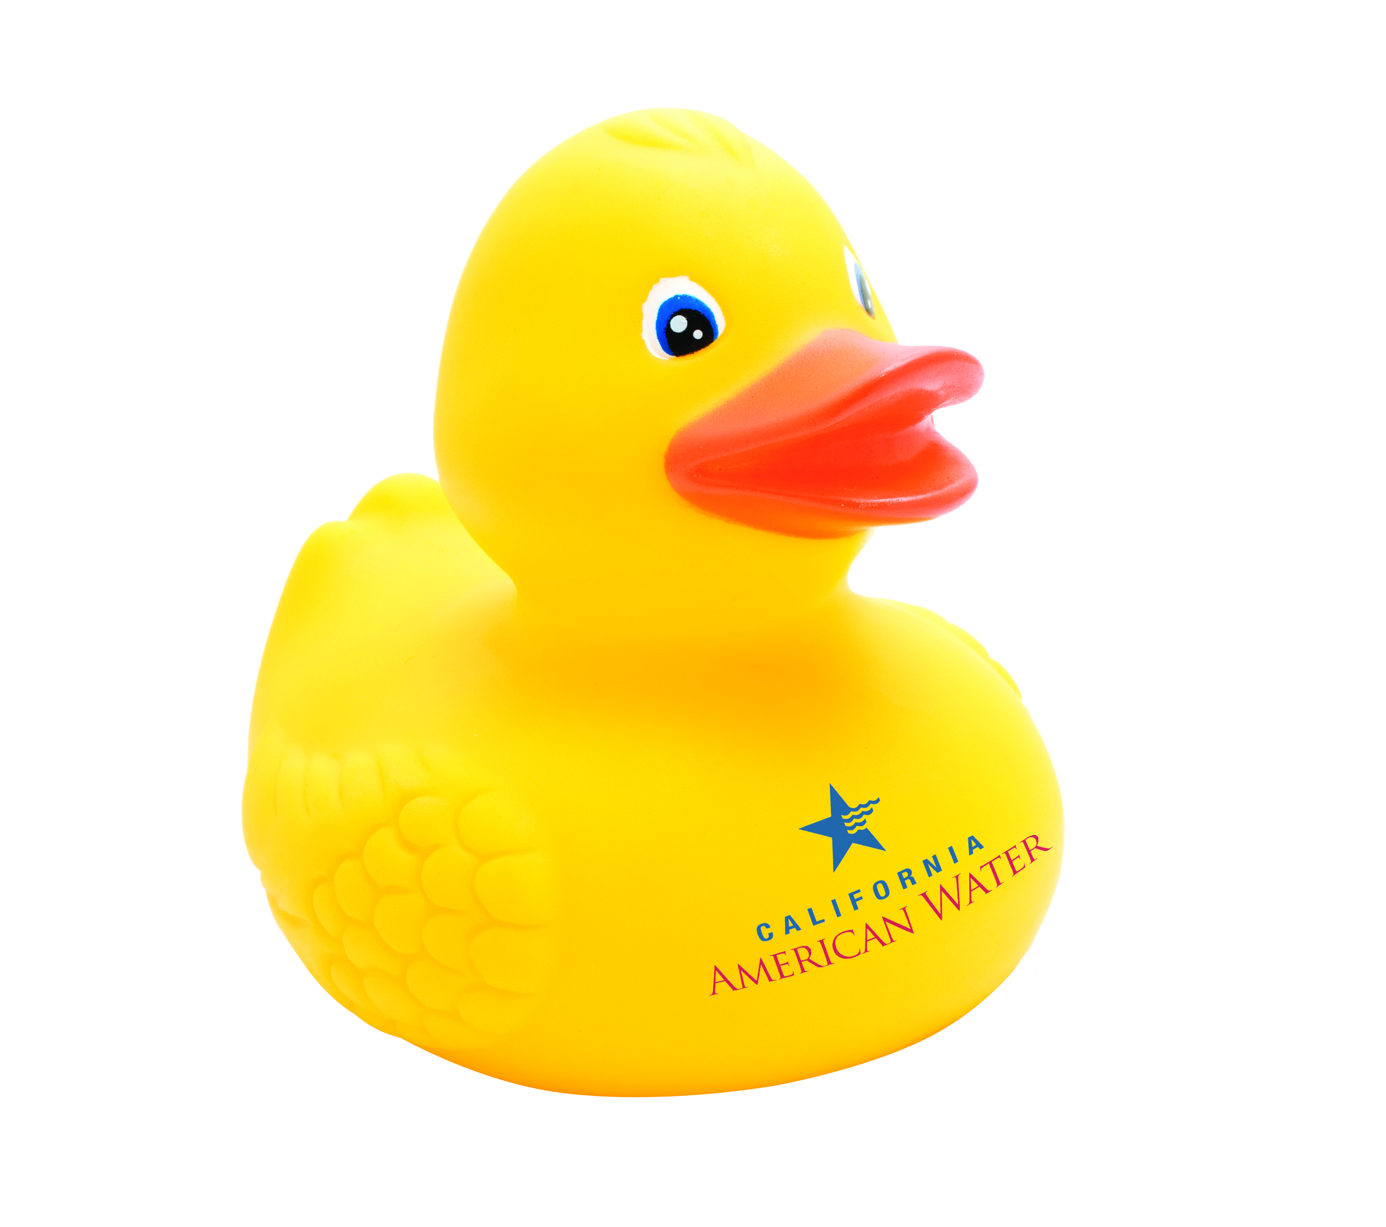
Word | Unscramble | Draw a line to match with its definition! | Definition
t a e r w | Water |  | The study of water
q a e u i r f |  |  | A large body of water, smaller than the ocean
l e l w |  |  | A body of water that moves downhill out to the ocean
v i r r e |  |  | Chemical symbol H₂0
k l a e |  |  | A body of water that is underground
m d a |  |  | A hole deep in the ground where we get water from
g o l h y y r d o |  |  | A device used to hold water back, sometimes providing hydro-electric power

Answers! | word | definition
t a e r w | Water | Chemical symbol H₂0
q a e u i r f | Aquifer | A body of water that is underground
l e l w | Well | A hole deep in the ground where we get water from
v i r r e | River | A body of water that moves downhill out to the ocean
k l a e | Lake | A large body of water, smaller than the ocean
m d a | Dam | A device used to hold water back, sometimes providing hydro-electric power
g o l h y y r d o | Hydrology | The study of water

